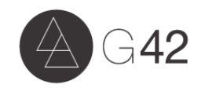
Venmo

To make your donation through Venmo, please use the following link https://www.venmo.com/Generation42 or type “Generation Forty Two” or “@Generation42” into your Venmo account to find us.

Please comment 50K Match on your donation, so we know which account to put the funds in.

G42, Inc. – The 42nd Generation U.S.A.: 501 (c)(3) reg. no. 26-0734218

